Technical Summary of Rigid Demo

The Rigid Demo contains a small simulator that allows deforming 3D meshes in real time. It is based on an algorithm called “As Rigid As Possible” (ARAP: http://igl.ethz.ch/projects/ARAP/). Since there is a really good implementation available (https://github.com/libigl/libigl) only a wrapper was written that allows for easy control of the simulation core.

While the simulation core is written in C++, the GUI including the 3D viewer is written in C#. The Rigid Demo adds code to compute a low resolution mesh from a high resolution mesh (implementation taken from here: https://github.com/smiley22/MeshSimplify and the corresponding paper: https://www.cs.cmu.edu/~./garland/Papers/quadrics.pdf). The meshes need to be topologically watertight in order to work without trouble. Afterwards a mapping from the low resolution mesh to the high resolution mesh is computed. This allows running the simulation with reduced computational effort which is required to achieve real time performance because starting from about 1000 triangles in the simulation mesh, the simulation performance starts to degenerate noticeably. The mapping is quite simple and fast: The basic idea is to assign each point of the high res mesh to the closest triangle in the low res mesh. Then the barycentric coordinates are computed. Afterwards a pattern search optimizer runs that modifies the barycentric coordinates trying to align the direction of the interpolated normal on the triangle with the direction from the base point on the triangle to the high resolution point.

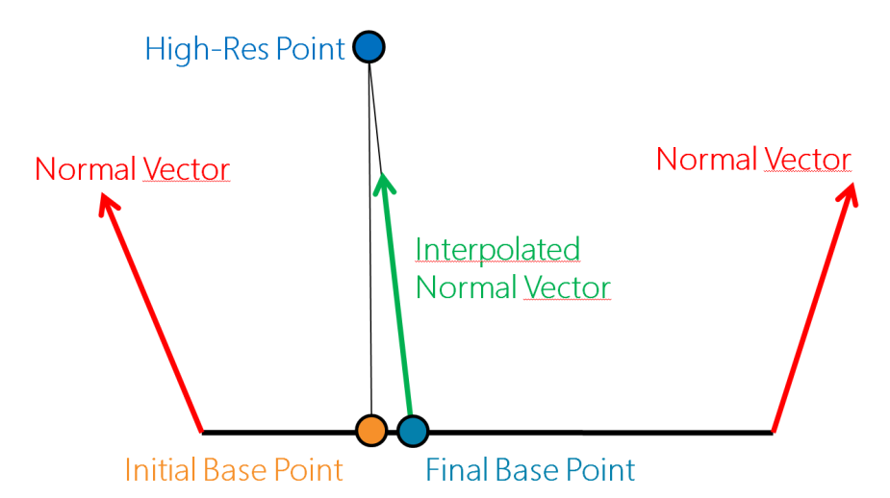

To evaluate the mapping, the triangle, the barycentric coordinates of the final base point and the distance from the final base to the high resolution point are required.

The user Interaction is done entirely in the 3D viewer. Selection can be done using the right mouse button. The appearing interactive 3D coordinate systems can be placed freely in space and the mesh will follow their location.